Rameet Sandhu

Justin Jaunay

Chad Stone

Santino Milan

Nicholas Jurgens

Hongni Liu

**Project Phase 2**

Table of Contents

*Part I: Project Planning*

*Part II: SC Strategy and Demand Forecasting*

*Part III: MIT Beer Game*

*Part IV: Estimating Historical Demand*

1. During this phase of the project you should be actively working on SC Strategy, **demand forecasting,** and, if possible, inventory management for your product.
   1. Hongni Liu
2. Play the “MIT Beer Game”, and create (customize) a similar game for your own product.
   1. Rameet
   2. Maymay
3. When estimating historical demand for your product, use (1) the product life-cycle model, and (2) the market analysis, and (3) cash-flow analysis that you performed last quarter.
   1. Chad
   2. Santino
4. The team should also be actively building the software platform or “architecture” (in Excel) to manage the supply chain, in particular the demand-forecasting module. You are expected to build on your **experience** and **expertise** in programming and product design from courses such as CS 12A, CS12B, CS 180/182, TIM 58, and TIM 105 when developing the software product to simulate and manage your supply chain.
   1. Justin
   2. Nick
   3. Milan
5. Meet with the instructor on 02/07/2017 to review your work.

***Part I: Project Planning***

1. **Define the Problem**
   1. Work on SC Strategy,demand forecasting
   2. Create similar game for our own product “MIT Beer Game”
   3. Estimate historical demand for our product
      1. Product life-cycle model
      2. Market analysis
      3. Cash-flow analysis
   4. Build the software platform or “architecture to manage the supply chain
   5. Meet with professor
2. **Create a Plan**
   1. **Step 1:** TheSupply chain for Your Company’s Proposed New Product
      1. **Step 1.1:** Clearly state the intent of the project
      2. **Step 1.2:** Determine the design/development sub-tasks and activities
      3. **Step 1.3:** Create a design/development activity matrix purpose to understand the dependencies between the sub-task
      4. **Step 1.4:** Create a schedule of tasks using a GANTT chart
      5. **Step 1.5:** Identify the “critical path” for the project sing PERT chart
      6. **Step 1.6:** Assign clear roles and responsibilities for each subtasks/activities
3. **Execute the Plan**
   1. **Step 1: Project Plan**
      1. **Step 1.1:** The intent of of the project is to create a smart trash can. Our company name is Purga. The smart trash can sort garbages, recycling, and compost into appropriate bins. The trash can has 5 bins, 1 for garbages, 2 for recycling, 1 for compost and 1 for waste.
      2. **Step 1.2:** Sub-tasks and activities
         1. **A**: SC strategy, demand forecasting
         2. **B**: create similar game for our own product
         3. **C**: estimate historical demand for our product
         4. **D**: Build software platform
         5. **E**: meet with professor
      3. **Step 1.3:** Activity Matrix

|  |  |  |  |  |  |
| --- | --- | --- | --- | --- | --- |
|  | A | B | C | D | E |
| A | A |  |  |  |  |
| B |  | B |  |  |  |
| C |  |  | C |  |  |
| D |  |  |  | D |  |
| E | X | X | X | X | E |

Notation:

X = “depends on”

BxA = subtasks B depends on subtask A

* + 1. **Step 1.4:** Gantt Schedule

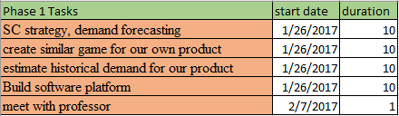

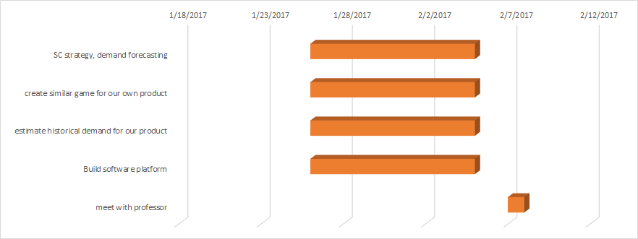

* + 1. **Step 1.5:** PERT chart



* + 1. **Step 1.6:** clear roles

|  |  |
| --- | --- |
| **Group Member** | **Role: (all include research)** |
| Rameet Sandhu |  |
| Santino Milan | Historical demand (support) software, platform (support) |
| Justin Jaunay | Project planning, software platform, Beer Game |
| Nick Jurgens | software platform |
| Hongni Liu | SC strategy, demand forecasting |
| Chad Stone | Historical demand |

1. **Draw Conclusions**

* Team will separate in groups of two and work together
  + Working together will allow a better overall work as partners can catch mistakes
* Three group meeting,
  + monday 1/30/2017
    - Discuss what needs to be worked on throughout the week
  + Friday 2/03/2017
    - Discuss what was worked on and what was troubling. Ask for help if problems arise
  + Monday 2/06/2017
    - Discuss each part and make sure every group member knows what was worked on. Final touches before meeting

***Part II: SC Strategy and Demand Forecasting***

**Define the Problem:**

* Define the SC strategy, marketing size, and demand forecasting; if possible, inventory management for the product.

**Plan the Treatment:**

* **Define the following:**
  + SC strategy
    - Draw and define IDU
    - Define competitive strategy
    - Map the resp/eff trade off and resp/eff spectrum
  + Marketing size
  + Demand forecasting
    - Plot demand actual data
    - Calculate the deseasonalized demand
    - Calculate regressed deseasonalized demand
    - Calculate seasonal factor
    - Calculate average seasonal factor
    - Forecast and plot the result
    - Calculate error, absolute error, squared error, MAD, MAPE, and TS.
    - Draw conclusions about the method according to the errors.
* Inventory management for the product （if possible)

**Execute the Plan:**

* SC strategy
  + Draw and define IDU



***Introduction & Decline***: Give High IDU

***Growth***: Low IDU

***Maturity***: Gives Medium IDU

In the figure abovewe see that Purga has high IDU because this is a new product and a new company We have compared other smart trash can companies who also have high IDU because they have just created their product and are doing pre-orders before they manufacture their products. iRobot gives somewhat high IDU because it is in the decline and not many consumers are buying their products as opposed to Simplehuman which is another trashcan company which has low IDU because they are getting a lot of demand and number 1 in the trashcan market.

* Define the competitive strategy



Our company starts with high IDU then will move towards low IDU which indicates that the competitive strategy of our company at the moment is a Focus Strategy. Right now our product is specifically targeting more eco-friendly customers, cities, and campuses. But as the Smart Trash Can becomes more popular, we will need to adjust our competitive strategy in order to appeal to all customers. Therefore in the future, our company’s competitive strategy is differentiated strategy.

* Resp/eff trade off and resp/eff spectrum
  + SC Efficiency:
    - Cost of making: $12 Million (This number is from TIM 105 Final Report)
    - Sorting: Unknown
    - Delivering the product to the customer: $235/container import from Mexico.
      * http://acetool.commerce.gov/shipping
  + SC Responsiveness:
    - Customer need large changes in quantity demanded: Customer needs is the number 1 importance for us
      * (HOQ TIM 105 Final Report)
    - Large range of products (product variety): uncertainty/unknown
    - High innovative products: Our software technology will constantly renew (see above)
    - Short lead-times: may require long time production in advance
    - High service levels: uncertainty/unknown
* (Resp/eff. spectrum)



* (Resp/eff. map)



* (2-D space)



* **Marketing size:**
  + We should be able to sell to 35,000 consumers throughout the country. This is the number that we are going to use for the demand of the first year.
  + The number is from TIM 105 Final report
* **Demand Forecasting:**
  + The numbers are continued from TIM 105 Final report. 4 years prediction. We assume the installation units for first year is 35,000 so we put 35,000 demand for quarter 4. By the second year, we assume over 120,000 demand will be proceed because we are starting to get known by the public and based on the research on other companies (i.e. Bruno or iRobot), they received a large amount of increasing revenue on year 2. We assume that as the year goes on, we will have a larger demand on year 3. And then we will experience a downward slope on the demand graph in year 4.
  + Plot the data, and find out that the data has seasonality.

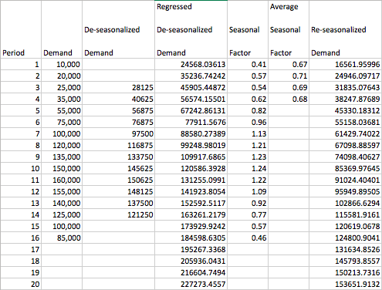Screen Shot 2017-02-06 at 10.49.26 PM.png

* Error

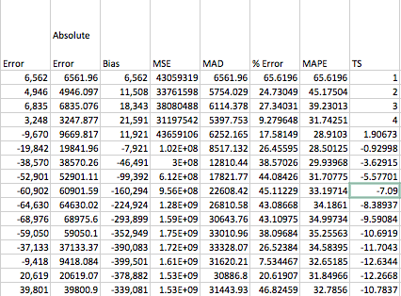

* Regression

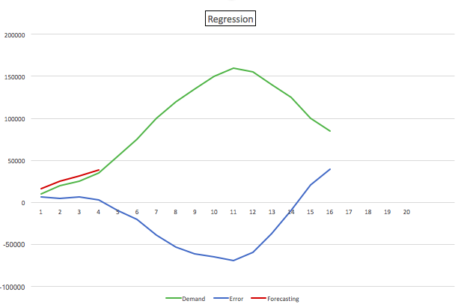

* **Inventory Management** 
  + (Not sure how to do it)

**Draw the Conclusion**

Our MAPE and TS values seem really good.This forecasting is acceptable. However, this forecasting number can only shows the next upcoming 4 quarters. Needs more actual datas in order to predict the future.

***Part III: “MIT Beer Game”***

1. **Define the Problem:**
2. Create a game similar to the “MIT Beer Game” for your own product

**II. Plan the Treatment:**

1. Read the handout on “MIT Beer Game” on the course website.
2. Play the “MIT Beer Game”
3. Construct the new game:
   1. Break it down by customer, retailer, wholesaler, distributor, manufacturer, and supplier
   2. Make two phases per period:
      1. Phase 1: Goal of the phase is to fill incoming orders and replace a replenishment order and repeat for each of the four stages: retailer, wholesaler, distributor, & manufacturer.
      2. Phase 2: Each of the four stages have their own process in phase 2
         1. Activities for Retailer:
         2. Activities for Wholesaler:
         3. Activities for Distributor:
         4. Activities for Manufacturer:

**III. Execute the Plan:**

1. Read the handout on “MIT Beer Game” on the course website.
2. Play the MIT game
   1. Due to difficulty in weather and schedule we decided to run the simulation online over skype
   2. Simulation found at
      1. <https://www.runthemodel.com/models/run.php?popup=1&id=507>

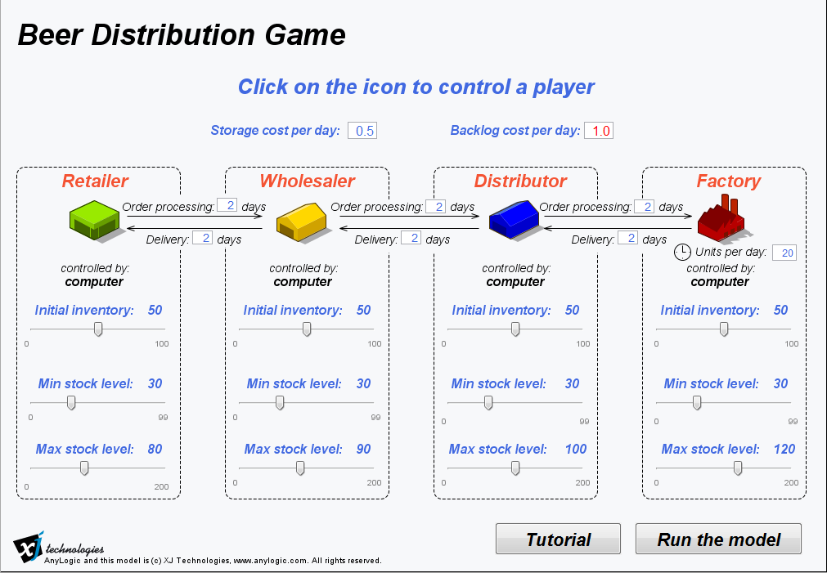

* + 1. Important notes to see, it takes 4 days for the company to receive an order after requesting it, Backlog Costs are 1.0$ per day and storage cost are 0.5$ per day
  1. 4 players played the game, each with their respective roles, multiple attempts were played in attempt to understand the game
     1. 1st attempt
        1. Each player orders only the amount needed to replenish their inventory after an order has been passed
           1. Retailer starts first and continuously requests as orders come in
           2. Wholesaler only starts requesting once the order has been received (i.e 3rd day)
           3. Distributor only starts requesting once the order has been received (i.e 5th day)
           4. Factory only starts fabricating once the order has been received( i.e 7th day)
        2. This was problematic as by the time the factory starts making anything both the retailer and the wholesaler are severely under stocked with inventory. They are unable to meet the amount of orders and their backlog price increases
        3. By the 20th day as the figure below shows the data does not seem very convincing. Although shipments started to catch up becauses orders tapered off, probably as a result of the lack of items being shipped to the consumers for the past 16 days, the damage had already been done with Backlog costs exceeding the 650 for retailers.

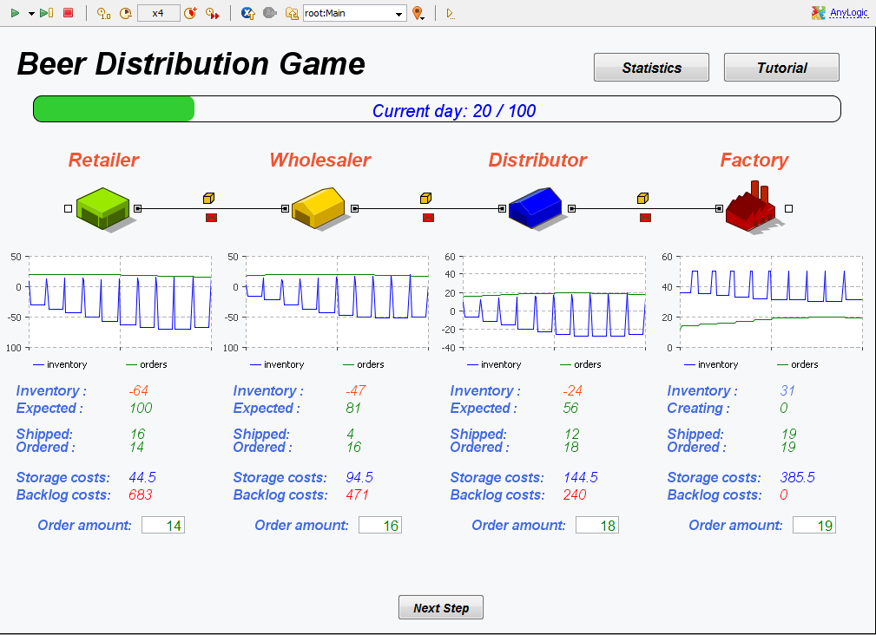

* + 1. 2nd attempt
       1. With this attempt we tried to look at what we could do to minimize backlog costs. To do this we allowed companies to order as they much as they wished, with the only restriction that the factory can only create 20 at a time
          1. Retailer starts first and continuously requests as orders come in, he did so until his inventory started to be lower and incurred high backlog costs
          2. Wholesaler followed the same example as the retailer, until round 5 started increasing its inventory request by 2 or 3 compared to the ordered category
          3. Distributor only starts requesting on 2 days after the game started, and follows the wholesaler, continues and increases the orders by 3
          4. Factory only starts fabricating 2 days after the distributor started, and has consistently been producing the max as a whole slew of orders are coming in
       2. This was a good attempt, apart from the retailer that needed to order a greater quantity to keep backlog lower than it was. By the 20th day as the figure below shows the data does seem more convincing.

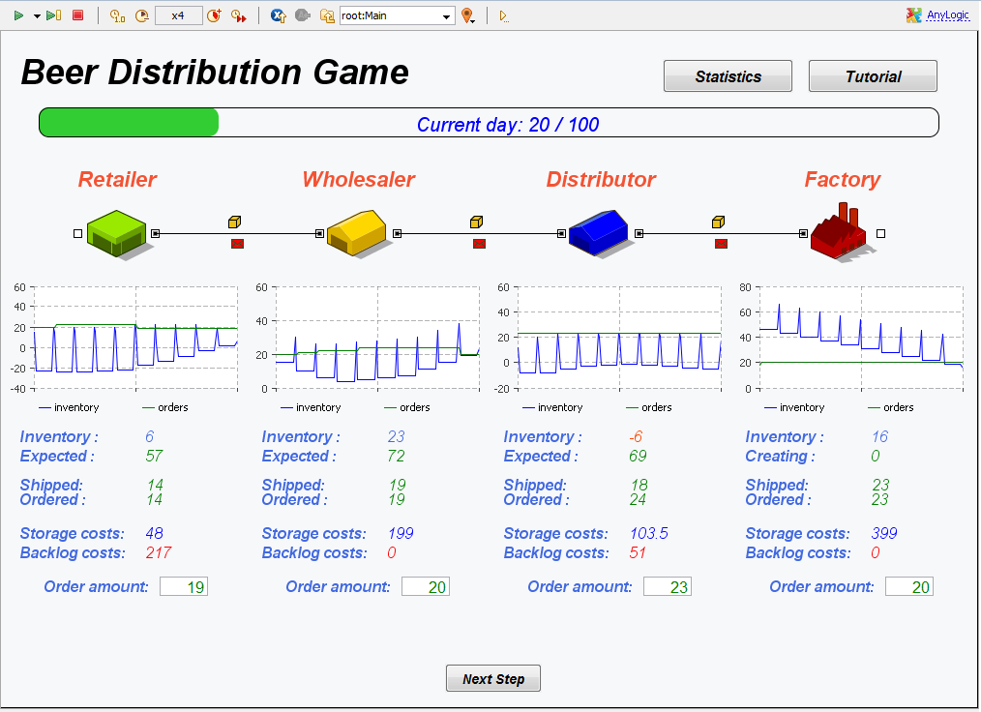

* + 1. 3rd attempt we played the game to simulate our supply chain, to be specific we had the Factory and the Distributor are push while the retailer and wholesaler are pull
       1. Retailers and wholesalers only order when they need to, although the amount is up to them. The factory and distributor can anticipate the order and amount as they wish.
       2. This attempt was a relatively good one, although because of the less constraint on what each respective needs, this allowed each respective company liberty to order how many shipments they wish. By the 20th day as the figure below shows the data does seemed convincing

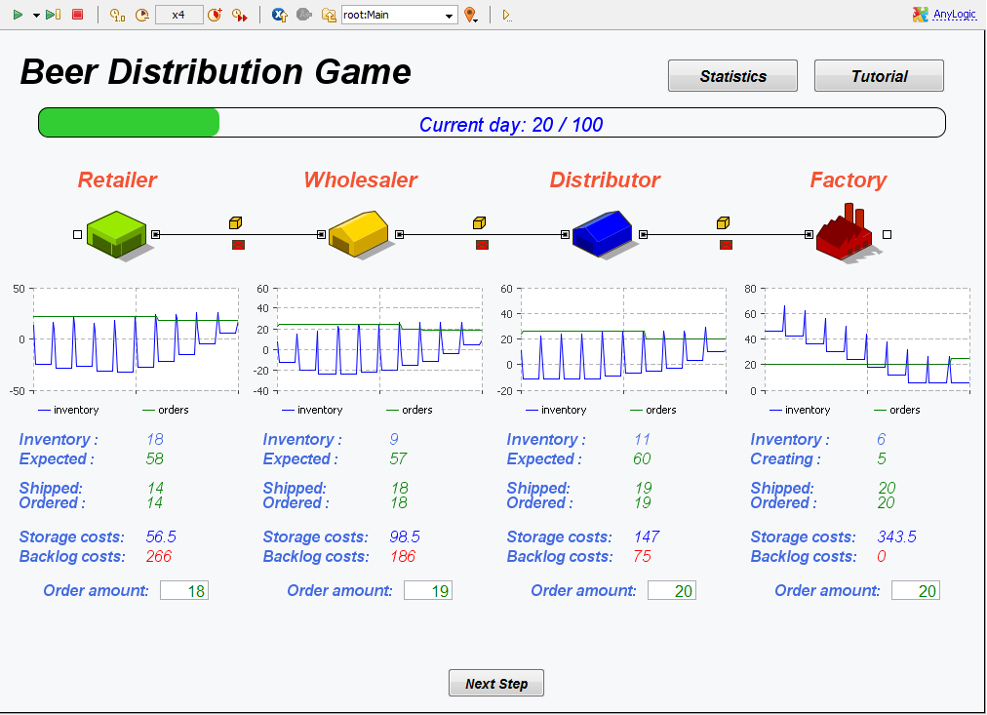

* + 1. New Beer game
       1. We would spread the game to include our suppliers of raw materials and components. Depending on the number of players we can increase the number of suppliers to fit what it represents in our system
       2. In addition we would personalize the time it takes to get our supplies and shipment times depending on actual data
       3. The supplier, the manufacturer are the only ones that can predict incoming shipments and can make inventory before a demand request comes in
       4. The manufacturer has some time that needs to be allocated for the creation of the product which must be taken into account
       5. The retailer and distributor can only make a demand for inventory when a demand has come in. Although once the order has come they can ask for as much as they wish.
       6. One last requirement of the new game is that each player must communicate with each other before each round what is coming to the respective player. Say the manufacturer needs supplies of raw materials, the supplier would tell the manufacturer what supplies are coming which day. This is done so that each player knows exactly what is coming and allows them to make a better decision on what they should request.
       7. These changes would be made in hopes to make the game work a bit better with how the Purga’s supply chain runs.

***Part IV: Estimating Historical Demand***

**Define the problem:**

When estimating historical demand for your product, use (1) the product life-cycle model, and (2) the market analysis, and (3) cash-flow analysis that you performed last quarter

**Plan the treatment of the problem:**

1. Product life-cycle model:

* Refer back to Phase 1 and analyse the product life-cycle model that has already been created
* Check the lecture notes to ensure everything is correct

1. Market Analysis:

* Perform the structural analysis of the industry in which the company is either an active competitor, or a new entrant, or a substitute.
* Determine the existing competitive strategy of the company within the industry
* Determine the relationships between the company and the other players in the industry

1. Cash-Flow Analysis:

* Go back to Phase III of Purga’s group project for TIM 105 last quarter and use the cash flow analysis that was derived to estimate historical demand for the Smart Trash Can

**Execute the problem:**

1. Product Life-Cycle Model:



* Purga is still in the introduction phase of the product-life cycle model. The reason for this is because Purga is still in the process of locating suppliers and manufacturers that will meet the needs of our product. One of our competitors, Simplehuman, is another trashcan company that uses similar technology as our Smart Trash Can who is still in the growth phase of the product life-cycle model. Lastly iRobot who has products such as the Roomba which is somewhat comparable to our product in the technology aspect is approaching the decline phase of the model. Noticing the success of our competitors who have less advanced products than our Smart Trash Can indicates a high demand and a lot of growth for our product.

1. Market Analysis:

* Industry Description and Outlook: The global smart trash can market has been registering positive growth over the last few years and is shaping up to become one of the top competitive markets at a global level. With the rise in globalization, ample growth opportunities are being created in the market
* Information About Smart Trash Can Industry: One of the main market drivers in the Smart Trash Can industry are touchless trash bins offering convenience and preventing cross-contamination. This applies to a market looking to use a hands free trash can.
* Distinguishing Characteristics: Our product has distinctive features including our main design which is to sort the trash being disposed. This gives us a competitive advantage over the other trash cans in the Smart Trash Can market because there is not a product in the market that has the features Purga offers.
* Size of the Market: The market size is relatively small. There are not too many competitors and there are none with the functionality of Purga’s Smart Trash Can. And those that are in the Smart Trash Can market are for the most part still in the introduction phase of the product life-cycle model.

1. Cash-Flow Analysis:

* Over the course of 4 years, our project NPV is expected to be about $27,440,000.
  + This is according to our projected sales of 35,000 units.

**Draw conclusions:**

Overall, all the information regarding Purga’s Smart Trash Can life-cycle model, market analysis, and cash-flow analysis that was performed last quarter has been consolidated into the outline above. The Smart Trash Can is in the introduction phase of the life-cycle model however, there very few competitors in the market. Not only are most of the competitors in the introduction phase as well but they do not offer the same functionality as Purga’s Smart Trash Can which separates us from the rest of the competition. There’s also a high demand among universities across the country to transition to a more eco-friendly campus which our product can help accomplish. This is why we’re targeting to sell approximately 10,000 units per year which will yield an expected profit of $80,000,000 over 4 years